Question 3 (7 marks)

<EFOFEX>
id:fxd{7a6a0f69-1501-49c1-94f6-8175fbf3a95c}

FXData:
</EFOFEX>The diagram shows part of the curve  
with equation $$y=\begin{matrix}2 \\ \overline{5}\end{matrix} \sqrt{5^{2}-x^{2}}.$$

Use integration and the substitution $x=5\sin{θ}$ 
 to determine the shaded  
area in the first quadrant bounded by $x=0, y=0$ 
 and the curve.

Question 3 (7 marks)

<EFOFEX>
id:fxd{7a6a0f69-1501-49c1-94f6-8175fbf3a95c}

FXData:
</EFOFEX>The diagram shows part of the curve  
with equation $$y=\begin{matrix}2 \\ \overline{5}\end{matrix} \sqrt{5^{2}-x^{2}}.$$

Use integration and the substitution $x=5\sin{θ}$ 
 to determine the shaded  
area in the first quadrant bounded by $x=0, y=0$ 
 and the curve.

|  |
| --- |
| Solution |
| $$A=\int_{0}^{5}{\frac{2}{5}\sqrt{5^{2}-x^{2}}}dx$$ $$x=5\sin{θ}⇒dx=5\cos{θ}dθ$$ When $x=0, θ=0$ and when $x=5, θ=\begin{matrix}π \\ \overline{2}\end{matrix}$. $$A=\frac{2}{5}\int_{0}^{\frac{π}{2}}{\sqrt{5^{2}-5^{2}\sin^{2}{θ}}}×5\cos{θ}dθ \\ =2\int_{0}^{\frac{π}{2}}{5\sqrt{1-\sin^{2}{θ}}}\cos{θ}dθ \\ =10\int_{0}^{\frac{π}{2}}{\cos^{2}{θ}}dθ \\ =10\int_{0}^{\frac{π}{2}}{\frac{1}{2}\left(1+\cos{2θ}\right)}dθ \\ =5{\left[θ+\frac{1}{2}\sin{2θ}\right]}_{0}^{\frac{π}{2}} \\ =5\left(\left[\frac{π}{2}+0\right]-\left[0+0\right]\right) \\ =\frac{5π}{2}$$ |
| Specific behaviours |
| ✓ writes integral in terms of $x$ with correct bounds  ü relates $dx$ and $dθ$ ü adjusts bounds in terms of $θ$ ü writes and simplifies integral in terms of $θ$ ü replaces $\cos^{2}{θ}$ term using trig identity  ü correctly antidifferentiates  ü substitutes and simplifies to obtain area |

Question 7 (6 marks)

<EFOFEX>
id:fxd{38367136-9c86-4a34-baa3-924658b028dc}

FXData:
</EFOFEX>The graph of is shown.

Determine the volume of the solid of revolution  
formed when the part of the curve between $x=0$ 
 and $x=6$ is rotated about the $x$-axis.

Question 7 (6 marks)

<EFOFEX>
id:fxd{38367136-9c86-4a34-baa3-924658b028dc}

FXData:
</EFOFEX>The graph of is shown.

Determine the volume of the solid of revolution  
formed when the part of the curve between $x=0$ 
 and $x=6$ is rotated about the $x$-axis.

|  |
| --- |
| Solution |
| $$V=\int_{0}^{6}{πy^{2}}dx \\ =π\int_{0}^{6}{\frac{25}{x^{2}+7x+6}}dx$$ $$\frac{25}{x^{2}+7x+6}=\frac{25}{\left(x+1\right)\left(x+6\right)}=\frac{a}{x+1}+\frac{b}{x+6}$$ $$x=-1, a=25÷(-1+6)=5, x=-6, b=25÷\left(-6+1\right)=-5$$ $$V=5π\int_{0}^{6}{\frac{1}{x+1}-\frac{1}{x+6}}dx \\ =5π{\left[\ln\left(x+1\right)-\ln\left(x+6\right)\right]}_{0}^{6} \\ =5π{\left[\ln\left(\frac{x+1}{x+6}\right)\right]}_{0}^{6} \\ =5π\left[\ln\left(\frac{7}{12}\right)-\ln\left(\frac{1}{6}\right)\right] \\ =5π\ln\left(\frac{7}{2}\right)$$ |
| Specific behaviours |
| ✓ forms correct integral for volume  ü indicates need for partial fractions and factorises denominator  ü obtains partial fractions  ü rewrites integral using partial fractions  ü antidifferentiates and substitutes  ü correct volume, simplified |

Question 6 (7 marks)

(a) Determine the value of the constant $A$ and the value of the constant $B$ so that

$$\frac{5}{(3x-2)(x+1)}=\frac{A}{3x-2}+\frac{B}{x+1} .$$

(2 marks)

(b) Hence use the substitution $u=\cos{x}$ to determine

$$\int{\frac{5\sin{x}}{2\cos{2x}-\cos^{2}{x}+\cos{x}}}dx.$$

(5 marks)

Question 6 (7 marks)

(a) Determine the value of the constant $A$ and the value of the constant $B$ so that

$$\frac{5}{(3x-2)(x+1)}=\frac{A}{3x-2}+\frac{B}{x+1} .$$

(2 marks)

|  |
| --- |
| Solution |
| Combining RHS into single fraction and equating numerators: $$Ax+A+3Bx-2B=5⇒A-2B=5, A+3B=0$$ Hence $A=3$ and $B=-1$. |
| Specific behaviours |
| ✓ indicates appropriate method  ü solves for $A, B$ correctly |

(b) Hence use the substitution $u=\cos{x}$ to determine

$$\int{\frac{5\sin{x}}{2\cos{2x}-\cos^{2}{x}+\cos{x}}}dx.$$

(5 marks)

|  |
| --- |
| Solution |
| Simplify denominator $$2\left(2\cos^{2}{x}-1\right)-\cos^{2}{x}+\cos{x}=3\cos^{2}{x}+\cos{x}-2 \\ =3u^{2}+u-2 \\ =(3u-2)(u+1)$$ Also $$u=\cos{x}⇒du=-\sin{x}dx$$ Hence |
| Specific behaviours |
| ✓ simplifies denominator in terms of $\cos{x}$ ü correctly relates $dx$ and $du$ ü uses partial fractions to express integral in terms of $u$ ü obtains antiderivative with absolute value brackets  ü correct result in terms of $x$, and integration constant |

Question 7 (8 marks)

<EFOFEX>
id:fxd{8300724c-5003-4a6a-bc7e-88b9a73b2c5a}

FXData:
</EFOFEX>(a) The line and the curve are  
shown in the diagram. They intersect at the  
origin and at $x=1$.  
  
Determine the area between the curve and the  
line in the first quadrant.

(5 marks)

(b) Given that $\int_{4}^{6}{\underset{ }{\overset{ }{\begin{matrix}f(x) \\ \overline{ x^{2} }\end{matrix} }}}dx=5$, determine $\int_{2}^{3}{\underset{ }{\overset{ }{f\left(\begin{matrix}12 \\ \overline{\overset{ }{ x }}\end{matrix}\right)}}}dx$. (3 marks)

Question 7 (8 marks)

<EFOFEX>
id:fxd{8300724c-5003-4a6a-bc7e-88b9a73b2c5a}

FXData:
</EFOFEX>(a) The line and the curve are  
shown in the diagram. They intersect at the  
origin and at $x=1$.  
  
Determine the area between the curve and the  
line in the first quadrant.

(5 marks)

|  |
| --- |
| Solution |
| To determine area under curve let $u=x^{2}+1$, so that $du=2x dx,$ $x=0→u=1$ and $x=1→u=2$. Then $$\int_{0}^{1}{\frac{x^{2}}{x^{2}+1} 2x}dx=\int_{1}^{2}{\frac{u-1}{u}}du \\ =\int_{1}^{2}{1-\frac{1}{u}}du \\ ={\left[u-\ln{u}\right]}_{1}^{2} \\ =\left(2-\ln{2}-1+0\right) \\ =1-\ln{2}$$ Area under line is $\frac{1}{2}\left(1\right)\left(1\right)=\frac{1}{2}$.  Hence area between is $\frac{1}{2}-\left(1-\ln{2}\right)=\ln\left(2\right)-\frac{1}{2} \text{sq units}$. |
| Specific behaviours |
| ✓ chooses suitable substitution  ü writes integral in terms of $u$ ü obtains antiderivative  ü obtains area under curve  ü obtains area between |

(b) Given that $\int_{4}^{6}{\underset{ }{\overset{ }{\begin{matrix}f(x) \\ \overline{ x^{2} }\end{matrix} }}}dx=5$, determine $\int_{2}^{3}{\underset{ }{\overset{ }{f\left(\begin{matrix}12 \\ \overline{\overset{ }{ x }}\end{matrix}\right)}}}dx$. (3 marks)

|  |
| --- |
| Solution |
| Let $u=\begin{matrix}12 \\ \overline{\overset{ }{ x }}\end{matrix}$, so that $x=\begin{matrix}12 \\ \overline{ u }\end{matrix} , dx=- \begin{matrix}12 \\ \overline{\overset{ }{ u^{2}}}\end{matrix} du$, $x=2→u=6$ and $x=3→u=4$.  Then $$\int_{2}^{3}{f\left(\frac{12}{x}\right)}dx=\int_{6}^{4}{f\left(u\right)}\left(-\frac{12}{u^{2}}\right)du \\ =-(-12)\int_{4}^{6}{\frac{f\left(u\right)}{u^{2}}}du \\ =12×5=60$$ |
| Specific behaviours |
| ✓ chooses substitution and relates $dx$ and $du$ ü writes integral in terms of $u$ ü derives correct value |

Question 1 (5 marks)

(a) Determine $\int_{ }^{ }{\underset{ }{\overset{ }{\cot\left(2x\right)}}}dx$. (2 marks)

(b) Evaluate $\int_{0}^{\frac{π}{2}}{\underset{ }{\overset{ }{\left(3-\sec^{2}\left(\begin{matrix}x \\ \overline{2}\end{matrix}\right)+3\tan^{2}\left(\begin{matrix}x \\ \overline{2}\end{matrix}\right)\right)}}}dx$. (3 marks)

Question 1 (5 marks)

(a) Determine $\int_{ }^{ }{\underset{ }{\overset{ }{\cot\left(2x\right)}}}dx$. (2 marks)

|  |
| --- |
| Solution |
|  |
| Specific behaviours |
| ✓ writes in form $f^{'}\left(x\right)÷f(x)$ ü correct integral with constant |

(b) Evaluate $\int_{0}^{\frac{π}{2}}{\underset{ }{\overset{ }{\left(3-\sec^{2}\left(\begin{matrix}x \\ \overline{2}\end{matrix}\right)+3\tan^{2}\left(\begin{matrix}x \\ \overline{2}\end{matrix}\right)\right)}}}dx$. (3 marks)

|  |
| --- |
| Solution |
| $$\int_{0}^{\frac{π}{2}}{3-\sec^{2}\left(\frac{x}{2}\right)+3\tan^{2}\left(\frac{x}{2}\right)}dx=\int_{0}^{\frac{π}{2}}{2\sec^{2}\left(\frac{x}{2}\right)}dx \\ ={\left[2(2)\tan\left(\frac{x}{2}\right)\right]}_{0}^{\frac{π}{2}} \\ =4$$ |
| Specific behaviours |
| ✓ simplifies  ü antiderivative  ü evaluates |

Question 2 (5 marks)

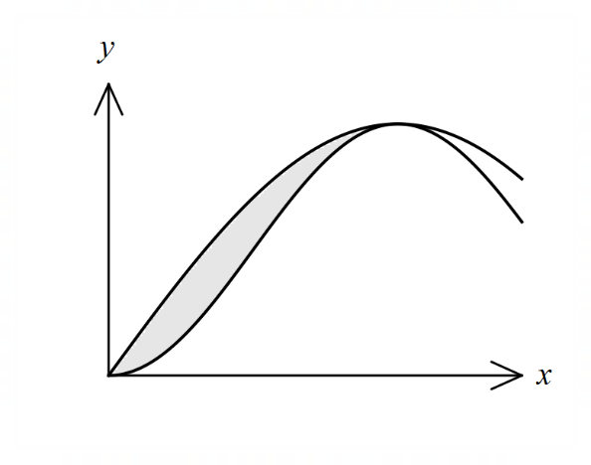The curves $y=3\sin\left(\begin{matrix}x \\ \overline{2}\end{matrix}\right)$ and $y=3\sin^{2}\left(\begin{matrix}x \\ \overline{2}\end{matrix}\right)$  
are shown to the right.

Determine the area of the shaded region  
trapped between the curves.

Question 2 (5 marks)

The curves $y=3\sin\left(\begin{matrix}x \\ \overline{2}\end{matrix}\right)$ and $y=3\sin^{2}\left(\begin{matrix}x \\ \overline{2}\end{matrix}\right)$  
are shown to the right.

Determine the area of the shaded region  
trapped between the curves.

|  |
| --- |
| Solution |
| $$3\sin\left(\frac{x}{2}\right)\left(1-\sin\left(\frac{x}{2}\right)\right)=0⇒x=0, π$$ $$A=\int_{0}^{π}{3\sin\left(\frac{x}{2}\right)-3\sin^{2}\left(\frac{x}{2}\right)}dx \\ =\int_{0}^{π}{3\sin\left(\frac{x}{2}\right)-\frac{3}{2}(1-\cos{x})}dx \\ ={\left[-6\cos\left(\frac{x}{2}\right)-\frac{3x}{2}+\sin{x}\right]}_{0}^{π} \\ =\left(0-\frac{3π}{2}+0\right)-\left(-6-0+0\right) \\ =6-\frac{3π}{2}$$ |
| Specific behaviours |
| ✓ indicates bounds  ü writes required integral  ü uses double angle identity  ü antidifferentiates  ü substitutes and simplifies |

Question 6 (6 marks)

(a) Express $\begin{matrix}6 \\ \overline{(u-3)(u+3)}\end{matrix}$ in the form $\begin{matrix}a \\ \overline{u-3}\end{matrix}+\begin{matrix}b \\ \overline{u+3}\end{matrix}$. (2 marks)

(b) Use the substitution $u^{2}=x+7$ to determine the indefinite integral $I$ shown below in the form $\ln\left(g\left(x\right)\right)+c$ for $x>2$. (4 marks)

$$I=\int{\frac{3}{\left(x-2\right)\sqrt{x+7}}}dx$$

Question 6 (6 marks)

(a) Express $\begin{matrix}6 \\ \overline{(u-3)(u+3)}\end{matrix}$ in the form $\begin{matrix}a \\ \overline{u-3}\end{matrix}+\begin{matrix}b \\ \overline{u+3}\end{matrix}$. (2 marks)

|  |
| --- |
| Solution |
| $$6=a\left(u+3\right)+b(u-3)$$ $$u=3⇒a=1, u=-3⇒b=-1$$ $$\frac{6}{(u-3)(u+3)}=\frac{1}{(u-3)}-\frac{1}{(u+3)}$$ |
| Specific behaviours |
| ✓ indicates appropriate method  ü correct partial fractions |

(b) Use the substitution $u^{2}=x+7$ to determine the indefinite integral $I$ shown below in the form $\ln\left(g\left(x\right)\right)+c$ for $x>2$. (4 marks)

$$I=\int{\frac{3}{\left(x-2\right)\sqrt{x+7}}}dx$$

|  |
| --- |
| Solution |
| $$u^{2}=x+7⇒2u du=dx$$ $$I=\int{\frac{3×2u}{{(u}^{2}-9)u}}du \\ =\int{\frac{6}{u^{2}-9}}du \\ =\int{\frac{1}{u-3}-\frac{1}{u+3}}du \\ =\ln\left(\frac{u-3}{u+3}\right)+c \\ =\ln\left(\frac{\sqrt{x+7}-3}{\sqrt{x+7}+3}\right)+c$$ |
| Specific behaviours |
| ✓ writes integral in terms of $u$ ü simplifies using result from part (a)  ü obtains antiderivative  ü writes in required form |

Question 1 (6 marks)

The function $f$ is defined by

$$f\left(x\right)=\frac{6}{{2x+x}^{3}}=\frac{ax}{x^{2}+2}+\frac{b}{x} .$$

(a) Determine the value of the constant $a$ and the value of the constant $b$. (3 marks)

(b) Hence, or otherwise, determine the value of $\int_{1}^{2}{\underset{ }{\overset{ }{f(x)}}}dx$ in simplest form. (3 marks)

Question 1 (6 marks)

The function $f$ is defined by

$$f\left(x\right)=\frac{6}{{2x+x}^{3}}=\frac{ax}{x^{2}+2}+\frac{b}{x} .$$

(a) Determine the value of the constant $a$ and the value of the constant $b$. (3 marks)

|  |
| --- |
| **Solution** |
| $$\frac{ax}{x^{2}+2}+\frac{b}{x}=\frac{ax^{2}+bx^{2}+2b}{x\left(x^{2}+2\right)}=\frac{6}{{2x+x}^{3}}$$ $$2b=6⇒b=3$$ $$a+b=0⇒a=-3$$ |
| **Specific behaviours** |
| ✓ combines fractions correctly  ✓ correct value of $a$ ✓ correct value of $b$ |

(b) Hence, or otherwise, determine the value of $\int_{1}^{2}{\underset{ }{\overset{ }{f(x)}}}dx$ in simplest form. (3 marks)

|  |
| --- |
| **Solution** |
| $$\int_{1}^{2}{\frac{3}{x}-\frac{3x}{x^{2}+2}} dx={\left[3\ln{x}-\frac{3}{2}\ln{(x^{2}+2)}\right]}_{1}^{2} \\ =3\ln{2}-\frac{3}{2}\ln{6}-\left(3\ln{1}-\frac{3}{2}\ln{3}\right) \\ =3\ln{2}-\frac{3}{2}\ln{2}-\frac{3}{2}\ln{3}-0+\frac{3}{2}\ln{3} \\ =\frac{3}{2}\ln{2}$$ |
| **Specific behaviours** |
| ✓ expresses integral using partial fractions  ✓ antidifferentiates  ✓ substitutes and simplifies |

Question 5 (5 marks)

Use the substitution $x=\sqrt{3}\tan{θ}$ to evaluate $\int_{0}^{1}{\underset{ }{\overset{ }{\begin{matrix}2 \\ \overline{x^{2}+3}\end{matrix}}}}dx$

Question 5 (5 marks)

Use the substitution $x=\sqrt{3}\tan{θ}$ to evaluate $\int_{0}^{1}{\underset{ }{\overset{ }{\begin{matrix}2 \\ \overline{x^{2}+3}\end{matrix}}}}dx$

|  |
| --- |
| **Solution** |
| $$dx=\sqrt{3}\sec^{2}{θ}dθ$$ $$x=0,θ=0; x=1, θ=\frac{π}{6}$$ $$x^{2}+3=3\tan^{2}{θ}+3 \\ =3\left(\tan^{2}{θ}+1\right) \\ =3\sec^{2}{θ}$$ $$\int_{0}^{1}{\frac{2}{x^{2}+3}}dx=\int_{0}^{\frac{π}{6}}{\frac{2\sqrt{3}\sec^{2}{θ}}{3\sec^{2}{θ}}}dθ \\ =\int_{0}^{\frac{π}{6}}{\frac{2\sqrt{3}}{3}}dθ \\ ={\left[\frac{2\sqrt{3}θ}{3}\right]}_{0}^{\frac{π}{6}} \\ =\frac{\sqrt{3}π}{9}$$ |
| **Specific behaviours** |
| ✓ obtains $dx$ in terms of $dθ$ ✓ changes limits  ✓ simplifies integrand  ✓ antidifferentiates integrand  ✓ evaluates definite integral |

Question 8 (9 marks)

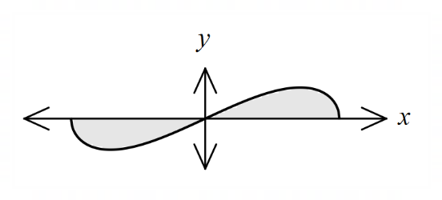(a) The graph of the curve $y=6x\sqrt{4-x^{2}}$  
is shown at right.

Using the substitution $u=4-x^{2}$,  
or otherwise, determine the area  
between the curve and the $x$-axis.

(6 marks)

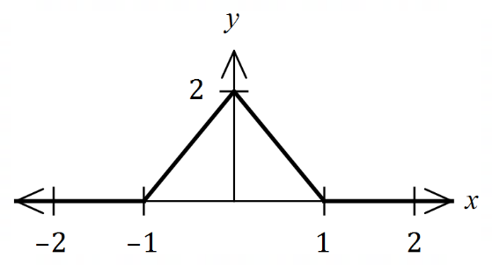

(b) The graph of $y=f(x)$ is shown at right.

Determine the value of $\int_{-1}^{1}{\underset{ }{\overset{ }{f(1-x^{2})}}}dx$.

(3 marks)

Question 8 (9 marks)

(a) The graph of the curve $y=6x\sqrt{4-x^{2}}$  
is shown at right.

Using the substitution $u=4-x^{2}$,  
or otherwise, determine the area  
between the curve and the $x$-axis.

(6 marks)

|  |
| --- |
| **Solution** |
| $$y=0⇒x=0, ±2$$ $$x=0, u=4, x=±2, u=0, du=-2x dx$$ $$\int_{0}^{2}{6x\sqrt{4-x^{2}}}dx=\int_{4}^{0}{-3u^{\frac{1}{2}}}du \\ ={\left[-2u^{\frac{3}{2}}\right]}_{4}^{0}=0-\left[-2{\left(4\right)}^{\frac{3}{2}}\right]=16$$ $$\int_{-2}^{0}{6x\sqrt{4-x^{2}}}dx={\left[-2u^{\frac{3}{2}}\right]}_{0}^{4}=\left[-2{\left(4\right)}^{\frac{3}{2}}\right]-0=-16$$ Hence . |
| **Specific behaviours** |
| ✓ indicates roots of graph  ✓ relates $du$ and $dx$ ✓ integral in terms of $u$ ✓ evaluates integral  ✓ repeats or uses symmetry to obtain second area  ✓ total area |



(b) The graph of $y=f(x)$ is shown at right.

Determine the value of $\int_{-1}^{1}{\underset{ }{\overset{ }{f(1-x^{2})}}}dx$.

|  |
| --- |
| **Solution** |
| Let $g\left(x\right)=1-x^{2}, -1≤x≤1$, so that $R_{g}: 0≤y≤1$.  But $R_{g}=D_{f}: 0≤x≤1$ and so $f\left(x\right)=2-2x$ (from graph).  Hence $f\left(1-x^{2}\right)=2-2(1-x^{2})=2x^{2}$ and so $$\int_{-1}^{1}{f(x^{2}-1)}dx=\int_{-1}^{1}{{2x}^{2}}dx={\left[\frac{{2x}^{3}}{3}\right]}_{-1}^{1}=\frac{2}{3}-\left(-\frac{2}{3}\right)=\frac{4}{3}$$ |
| **Specific behaviours** |
| ✓ justifies expression for $f(x)$ ✓ writes required integral  ✓ correct value |

(3 marks)

Question 5 (7 marks)

Determine

(a) $\int_{ }^{ }{\underset{ }{\overset{ }{\begin{matrix}5x+7 \\ \overline{x^{2}+3x+2}\end{matrix}}}}dx$. (3 marks)

(b) $\int_{ }^{ }{\underset{ }{\overset{ }{\begin{matrix}1 \\ \overline{{4+x}^{2}}\end{matrix}}}}dx$, using the substitution $x=2\tan{θ}$. (4 marks)

Question 5 (7 marks)

Determine

(a) $\int_{ }^{ }{\underset{ }{\overset{ }{\begin{matrix}5x+7 \\ \overline{x^{2}+3x+2}\end{matrix}}}}dx$. (3 marks)

|  |
| --- |
| **Solution** |
|  |
| **Specific behaviours** |
| ✓ indicates use of partial fractions  ✓ correct partial fractions  ✓ correct integral, including constant |

(b) $\int_{ }^{ }{\underset{ }{\overset{ }{\begin{matrix}1 \\ \overline{{4+x}^{2}}\end{matrix}}}}dx$, using the substitution $x=2\tan{θ}$. (4 marks)

|  |
| --- |
| **Solution** |
| $$dx=2\sec^{2}{θ}dθ$$ $$x^{2}=4\tan^{2}{θ} \\ 4+x^{2}=4+4\tan^{2}{θ} \\ =4\sec^{2}{θ}$$ $$\int{\frac{1}{4+x^{2}}}dx=\int{\frac{2\sec^{2}{θ}}{4\sec^{2}{θ}}}dθ \\ =\int{\frac{1}{2}}dθ \\ =\frac{θ}{2} \\ =\frac{1}{2}\tan^{-1}{\frac{x}{2}}+c$$ |
| **Specific behaviours** |
| ✓ relates $dx$ and $dθ$ ✓ uses trig identity  ✓ writes and simplifies integral wrt $θ$ ✓ integrates and writes wrt $x$ |

Question 8 (7 marks)

The graph of $y=x\sqrt{25-x^{2}}$ in the first quadrant is shown below.

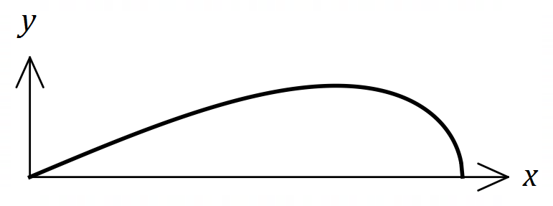

(a) Determine the area of the region shown between the curve and the $x$-axis. (4 marks)

(b) Determine the volume of the solid of revolution formed when the region between the curve, the $x$-axis, $x=0$ and $x=2$ is rotated about the $x$-axis. (3 marks)

Question 8 (7 marks)

The graph of $y=x\sqrt{25-x^{2}}$ in the first quadrant is shown below.



(a) Determine the area of the region shown between the curve and the $x$-axis. (4 marks)

|  |
| --- |
| **Solution** |
| $$A=\int_{0}^{5}{x{\left(25-x^{2}\right)}^{0.5}}dx$$ $$u=25-x^{2}⇒du=-2x dx$$ $$x=0⇒u=25, x=5⇒u=0$$ $$A=\int_{25}^{0}{-\frac{u^{0.5}}{2}}du \\ ={\left[-\frac{1}{3}u^{\frac{3}{2}}\right]}_{25}^{0} \\ =\left[0\right]-\left[-\frac{125}{3}\right]=\frac{125}{3} \text{square units}$$ |
| **Specific behaviours** |
| ✓ correct integral in terms of $x$ ✓ indicates valid integration method  ✓ integrates correctly  ✓ simplified area |

(b) Determine the volume of the solid of revolution formed when the region between the curve, the $x$-axis, $x=0$ and $x=2$ is rotated about the $x$-axis. (3 marks)

|  |
| --- |
| **Solution** |
| $$V=π\int{y^{2}}dx \\ =π\int_{0}^{2}{25x^{2}-x^{4}}dx \\ =π{\left[\frac{25x^{3}}{3}-\frac{x^{5}}{5}\right]}_{0}^{2} \\ =π\left[\left(\frac{200}{3}-\frac{32}{5}\right)-0\right] \\ =\frac{904π}{15} \text{cubic units}$$ |
| **Specific behaviours** |
| ✓ correct integral in terms of $x$ ✓ integrates and substitutes correctly  ✓ simplified volume |

Question 2 (5 marks)

Part of the graph of $y=1+\begin{matrix}5 \\ \overline{x(x-6)}\end{matrix}$ is shown below.

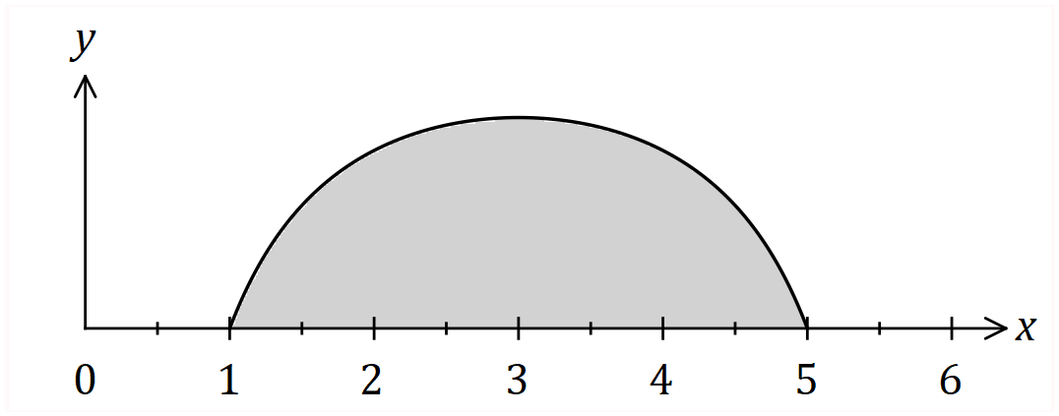

Determine the shaded area, bounded by the curve and the $x$-axis.

Question 2 (5 marks)

Part of the graph of $y=1+\begin{matrix}5 \\ \overline{x(x-6)}\end{matrix}$ is shown below.



Determine the shaded area, bounded by the curve and the $x$-axis.

|  |
| --- |
| **Solution** |
|  |
| **Specific behaviours** |
| ✓ integral, recognising need for partial fractions  ✓ obtains partial fractions  ✓ integrates  ✓ substitutes limits of integration  ✓ simplifies until just one logarithm remains |

Question 3 (4 marks)

The curve defined by $y=4\cos\left(\begin{matrix}πx \\ \overline{ 12 }\end{matrix}\right)$, where $0≤x≤3$, is shown below.

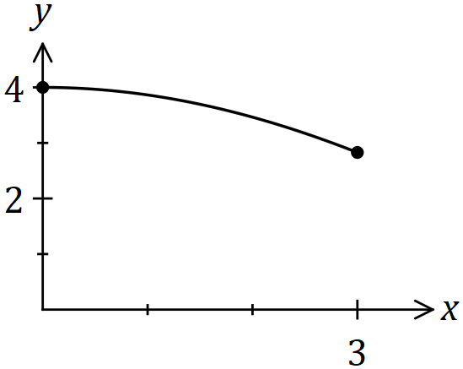

Determine the volume of the solid generated when the area bounded by the $x$ axis and the curve is rotated $360°$ about the $x$ axis between $x=0$ and $x=3$.

Question 3 (4 marks)

The curve defined by $y=4\cos\left(\begin{matrix}πx \\ \overline{ 12 }\end{matrix}\right)$, where $0≤x≤3$, is shown below.



Determine the volume of the solid generated when the area bounded by the $x$ axis and the curve is rotated $360°$ about the $x$ axis between $x=0$ and $x=3$.

|  |
| --- |
| **Solution** |
| $$V=π\int_{0}^{3}{y^{2}}dx \\ =16π\int_{0}^{3}{\cos^{2}\left(\frac{πx}{12}\right)dx} \\ =\frac{16π}{2}\int_{0}^{3}{\left(1+\cos\left(\frac{πx}{6}\right)\right)}dx \\ =8π{\left[x+\frac{6}{π}\sin\left(\frac{πx}{6}\right)\right]}_{0}^{3} \\ =8π\left(\left[3+\frac{6}{π}\right]-\left[0+0\right]\right) \\ =24π+48 \text{cubic units}$$ |
| **Specific behaviours** |
| ✓ writes integral  ✓ re-writes integral using double angle identity  ✓ integrates  ✓ substitutes both bounds and simplifies |

Question 3 (7 marks)

(a) Determine the slope of the graph of $x^{2}+y^{3}=3xy$ at the point $(2, 2)$. (3 marks)

(b) Use the substitution $u=2x^{2}+1$ to express $\int_{0}^{2}{\begin{matrix}12x \\ \overline{\sqrt{2x^{2}+1}}\end{matrix}} dx$ in terms of $u$ and hence evaluate the integral. (4 marks)

Question 3 (7 marks)

(a) Determine the slope of the graph of $x^{2}+y^{3}=3xy$ at the point $(2, 2)$. (3 marks)

|  |
| --- |
| **Solution** |
| $$2x+3y^{2}y^{'}=3y+3xy^{'}$$ $$4+12y^{'}=6+6y^{'}$$ $$y^{'}=\frac{1}{3}$$ |
| **Specific behaviours** |
| ✓ differentiates LHS  ✓ differentiates RHS  ✓ substitutes and simplifies |

(b) Use the substitution $u=2x^{2}+1$ to express $\int_{0}^{2}{\begin{matrix}12x \\ \overline{\sqrt{2x^{2}+1}}\end{matrix}} dx$ in terms of $u$ and hence evaluate the integral. (4 marks)

|  |
| --- |
| **Solution** |
| $$u=2x^{2}+1⇒du=4x dx$$ $$x=0, u=1; x=2, u=9$$ $$\int_{0}^{2}{\frac{3×4x}{\sqrt{2x^{2}+1}}} dx=\int_{1}^{9}{\frac{3}{\sqrt{u}}} du$$ $$={\left[6\sqrt{u}\right]}_{1}^{9}=18-6=12$$ |
| **Specific behaviours** |
| ✓ expresses integrand in terms of  ✓ changes limits  ✓ antidifferentiates  ✓ evaluates |